Recipedia

A social media platform for sharing, learning, and hosting culinary related content.

# Group 3 contributions:

* 300345000 – Minh Bui – 33.33%
* 300352582 – Ching Tung Lam – 33.33%
* 300296888 – Van Hai Ung – 33.33%

# Video Presentation:

[Group3-Recipedia-Video-Recording.MP4](https://collegedouglas-my.sharepoint.com/:v:/g/personal/buiq5_student_douglascollege_ca/EecAJLCw1hNHrjchhOHj5qoBoaWKkbSSYsAc5myU9qV_jw?e=IbpaLN)

# FIGMA Design:

<https://www.figma.com/file/U0Zf48YnmKghjCDgtf4y6X/Prototype?node-id=0%3A1&t=ykagun93gnMx5D2c-1>

Contents

Group 3 contributions: 1

Video Presentation: 1

FIGMA Design: 1

Introduction 3

Recipedia: A social platform recipes and cooking 3

Novelty 3

PACT elements 3

Background research 3

Existing apps on market 3

Requirements 4

Requirements gathering 5

Result insights 9

Stories and Scenarios 9

Design 12

Overview 12

Login and Register screens: 13

Social view 14

Post detail: 15

Filter-Recipe Courses screen: 16

Recipe Details screen: 17

Manage ingredients and Search/add ingredients screens: 18

Recipe view: 19

Recipes filter: 20

Create a new recipe: 21

Cook 101: 23

Conclusion: 23

# Introduction

## Recipedia: A social platform recipes and cooking

Cooking recipes have always been abundant on the internet. Nowadays, recipes from online articles and mobile apps are widely accessible. However, they don’t usually provide the exact thing people are looking for. Online articles are usually lengthy as the point of those articles is to keep users engaging as long as possible and draw attention to online advertisement. Mobile apps are handy, but often lack variety. Overall, those articles can sometimes miss crucial information such as heat level, cooking duration, vague ingredients and steps to prepare them, and the instructions don’t suit all skill level.

One solution to these problems is a social media platform for cooking with content created by users and for users. With the rise of social media platforms in the past decade and the need to learn to cook especially for single households, Recipedia is a service app that aims to capture this market.

## Novelty

The service’s novelty is coming from it being a social media platform. Contents for learning are being kept fresh and plentiful by having the users as the content creators. Similar to other social media platforms, the quality of content is determined by a rating system, user’s engagement statistic and a personalized user’s feed using an always evolving algorithm.

## PACT elements

Users are encouraged to post foods that they’ve made or ordered. Which is an activity that people do daily. They are also encouraged to come back to check with their friends and content creators’ activities.

Content creators are commissioned for drawing users’ engagement via various methods such as creating a new recipe, creating cooking tutorials, hosting events.

Other third parties can promote their culinary related contents such as kitchenware, meal kit delivery services, cooking courses and books via advertisement.

# Background research

## Existing apps on market

* SuperCook - Recipe Generator https://play.google.com/store/apps/details?id=com.supercook.app

SuperCook shares recipes from other websites and people to upload recipes. The reliability of those recipes is skeptical, especially those that do not have any reviews because the user would not know who the recipe provider is. Therefore, it inspires us to include some recipes provided by professional chefs along with recipes uploaded by users.

Moreover, what makes our app different from SuperCook app is that users can shop groceries within the app if they wish to buy missing ingredients, which SuperCook app cannot provide that convenience for its users. Additionally, if users do not want to be shopping, our recipe generator will offer substitute suggestions for the items they are missing. Finally, creativity is unlimited as chefs can view what people are cooking in different locations, what food photos they post in which location or simply read some useful stories of keeping fridge organized.

* Whisk: Recipes & Meal Planner https://play.google.com/store/apps/details?id=com.foodient.whisk

Whisk is featured in having healthy dining plans and having conversations with others to share receipts in the app. Having a healthy lifestyle is a hot topic nowadays so when people look for recipes, they would like to have some healthy options. The healthy dining plan feature makes this app favorable. Therefore, allowing users to filter recipes by calorie content and including it in the recipe cards would aid people to eat healthier. On the other hand, having conversations with friends and family makes the app interactive and exciting since people would love to share their experiences and get to know others’ stories. To achieve the same goal, Instagram story feature is referred. Through the community, users could share recipes that they have tried with comments and their own results. Then, users could swape right or left to get to the next friend’s post. Therefore, users not only get the recipes, but also get to know more about their friends.

* Empty my fridge - Plant Jammer https://play.google.com/store/apps/details?id=com.plantjammer.plantjammer

Empty my fridge is featured in a similar idea that provides recipes according to the food input. Unfortunately. it got much fewer downloads (500K+), than Whisk (1M+) and SuperCook (1M+). It may be caused by overly simplified functionalities. Some reviews mentioned that the app could not filter by type of dish, it lacked updated recipes and recipe-saving function, and many recipes were behind a paywall. Therefore, it inspired us to add more features to attract people and design the app from the users’ point of view are needed. It is believed that the inclusion of a community feature for sharing recipes and experiences with others and cooking 101 for beginners could make the app interesting and take people with various cooking experiences into consideration.

## Requirements

* Register and login.
* input ingredients in fridge
  + (For members) stored the ingredient in “my fridge”.
  + (For non-members) stored the ingredients temporarily.
  + Visualize them by showing the ingredients in the fridge.
* Search for recipes:
  + (For non-members) Search with input ingredients in fridge.
  + Results recipes
    - Filter: relevant (you have all the ingredients à you need to buy a few more ingredients), cooking time, difficulty levels, rating, calories content.
    - Click on the interested recipe to show the details on a recipe card (a pop-up window)
    - Recipe card: photos of the dish, ingredients needed, the amount of them, step-by-step instructions, cooking time, calories content, video tutorials, tips/reminder, share button (share via social media / community in the app), rating, and comments.
    - Save recipes.
    - After clicking the “I cooked it” button, the amount of ingredients would be reduced according to the recipe and provide share button to share the outcome via social media. Or user could do it manually by editing the “my fridge”.
* Community:
  + Share recipes and photos like Instagram story (swiping)
  + People could update their own recipe.
  + When you click on a person's account, you can see what they uploaded. It is beneficial for famous chefs to enhance their popularity by sharing recipes.
* Cooking 101
  + Guidance available for beginner chefs
    - e.g., what they would do to minimize food waste, how to use knife safely, how to deal with certain meat.

## Requirements gathering

The group designed an online survey with multiple choice questions that aimed to visualize the cooking habits, meal diet, and lifestyles of mobile users who are familiar with operating a smartphone as well as navigating online social media. The survey was sent to online connections of the group members via social media. As such, users who filled in these surveys are familiar with navigating mobile apps and social media.

The results are described in the graphs below: Food Recipe survey results:

Open answer – What problems do you have when looking for recipe (16 responses):

* Missing details such as heat level and duration.
* Do not have enough information
* Can’t find the exact one I want
* The recipes are shown in the youtube video
* Do not have enough other ingredients
* Sometimes, it is difficult for me to learn only through the text
* Conversion of gram to lb
* Simple while taste good and good looking
* n/A
* Hard to tell quality
* Hard to find
* None
* Nil
* It may be difficult to find the same ingredients
* It may be difficult to find the same ingredients

## Result insights

From the survey results, we conclude a few points that further suggest the need for an online social media platform for culinary:

* The majority of users cook more than 3 times a week, proving the potential user base for the platform is vast.
* Vegetables and bread are the type of food that often gets thrown away. This is due to this food being hard to keep fresh.
* While only a small portion of the user base often throws away food, users typically try to cook the unused ingredients using their own creativity or off of an online recipe. This shows that there’s a need for a better search algorithm and a plentiful database of content.
* The majority of users look for recipes from online articles and only a small portion use cooking apps. This is due to the content of these apps being just too little and there’s no incentive to come back to those apps.
* Most people agree that it’s hard to find recipes. This goes along with the assumption that online recipes and cooking apps are not useful due to the points mentioned in the prior introduction section.

## Stories and Scenarios

Based on requirement gathering results, we created 3 diversified personas to visualize the needs and possible scenarios for the app.

Persona: Sam

* Age 30
* Never cooked before
* Go to a new country. From Asian to Western
* Learn how to cook in order to save money on food expenses
* Make new friends to expand his network in a new country
* Has an active social life
* Works as a counselor
* Lives with a friend

1. He does not know what food to buy so he buys everything he finds interesting and thought that he would figure out how to cook that afterward. Eventually, he is overwhelmed by the fridge which is full of food that he does not know how to deal with.

2. He has less time to study cooking than he thought because he got so tired after work and does not have the energy to study cooking anymore.

3. His roommate introduces the Recipedia app to him. By using the app, he could get some recipes by inputting the ingredients in his fridge. So that he is no longer frustrated about searching for recipes when he does not have much idea what he wants to cook.

4. He could get very basic skills like how to chop meat and clean up vegetables from cooking 101. He could learn it quickly and easily. And he could get recipes in beginner level and done in short time by the filter. It shortens the time for searching for suitable recipes so that he could learn cooking fast while focusing more on work.

5. As a counselor, he loves to connect with people. He added some friends around his community. He can share photos of his dishes and the recipes he used with his friends via the social media platform in the app. He is so happy to interact with people, knows what people cook and comments from them too.

6. He loves to share his favorite Asian cuisine from his hometown while trying out the Western people's recipes shared in the community.

7. Also, he manages the ingredients in his fridge better. And he knows what to buy when he is in the market by viewing what is missing from the fridge via the app. And food waste and expense are minimized when he can buy what he needs only.

Persona: John

Age: 30

* Single.
* Intends to open a small restaurant.
* Aware of how much unused food he will be throwing away.
* Want to find ways to reduce the amount of food waste generated.
* Interested in sustainability and reducing waste, both in his personal life and in his business.
* He values sustainability and efficiency but also wants to make sure his business is profitable.
* John's main goal is to reduce food waste and save money for his restaurant while maintaining the quality of the meals they serve.

1. John uses a food waste app called "Recipedia" to help solve the food waste generated by his restaurant.

2. He inputs the types and quantities of food waste, and the app provides suggestions for different meals.

3. The app helps John to keep track of the food in his fridge and allows him to use up all his ingredients left before they go bad.

4. He regularly updates his menu to include dishes made from leftover ingredients, which he markets as sustainable specials.

5. He wants to build a sense of community and connection with his customers by sharing his new leftover dishes and getting feedback. He also wants to promote sustainability and set an example for others in his industry.

6. The app allows him to create his own unique recipes that no other restaurant has.

7. With Cook 101 feature, he can learn to cook a variety of dishes and then customize those to his liking to enrich the menu.

Persona: Sophia

Age: 38

* Housewife
* Married and have 2 children in teenager age.
* Cook every day for her children and husband.
* Has a healthy lifestyle and nutrition diet.
* Not good with technology

1. She learnt how to cook when she was young from her mother who also cooks every day.
2. She cooks every day and has become proficient at cooking and grocery shopping. She can improvise with unused ingredients. She can also come up with what to cook on the spot when shopping for groceries.
3. She is not good with technology. She can operate a smartphone, use social media apps and play simple puzzle games. She does not know how to use a computer.
4. She wants to learn more cooking recipes to further expand her skillsets.
5. Sophia has learnt lots of recipes from online articles and recipe apps. Although most recipes are incomplete or not well-written, which might cause trouble for people who have only started to learn how to cook, Sophia can still manage to improvise and create meals out of them.
6. Most online recipes are repetitive. She needs to find new and trending recipes and as such, needs a social media platform for cooking where people can find recipes by popularity.
7. Although her diet is already healthy due to having a wide range of ingredients used in her cooking, she wants to know more up-to-date nutrition facts.

# Design

## Overview

Main screens: Social media view, Recipes View and Cook 101

Envisionment:

1. Purpose and goals:

* To reduce food waste by providing practical solutions and incentives for users to manage their food consumption.
* To help users manage the ingredients in their fridge better and know what they need to buy in the market by viewing what is missing in the fridge via app.
* To teach users some basic cooking skills through cooking 101 feature.
* To connect users from all over the world and allow them to share their best cooking moments.

2. Target Audience:

* Households are looking to reduce their food waste and save money on groceries.
* Businesses and organizations that generate a significant amount of food waste are looking to implement sustainable practices.
* Individuals looking to connect and share some advice with others who are struggling with what to cook and how to manage their fridge more efficiently.

3. Features:

* Meals and recipes sharing posts based on leftover ingredients to reduce waste and save money.
* Food ingredients tracking and monitoring to help users identify patterns and make informed decisions about their food consumption.
* Social media sharing platform to increase user engagement and promote a sense of community around the issue of food waste.
* Education and resources to help users learn and expand their skillsets.

Task analysis:

1. Tracking and monitoring ingredients:

* Inputting the type and amount of ingredients daily
* Identifying leftover ingredients in fridge to make informed decisions about future grocery or meal planning.

2. Creating meal plans and finding recipes:

* Finding recipes that utilize leftover ingredients.
* Generating recipe posts based on filter selection.
* Browsing recipe options based on ingredients on hand.
* Rating, reviewing and commenting recipes to help other users make informed decisions.

3. Connecting and sharing with others:

* Creating and posting a new recipe.
* Posting details on how to make a specific dish.

4. Education:

* Providing basic cooking skills.
* Proving a number of unique cooking recipes to further expand one’s skillsets.
* Allow users to customize their meals based on a variety of dishes.

## Login and Register screens:

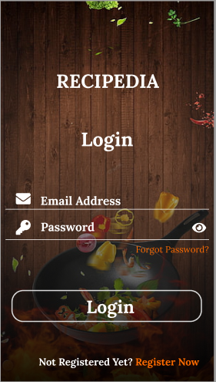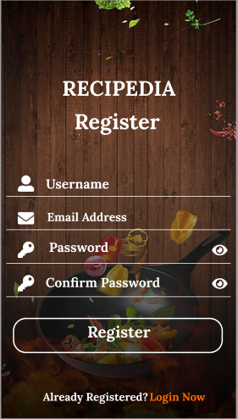

If users already have an account, they can enter the email address and password to login. Notice that there is an eye icon in the right-hand side that allows users to check whether they enter password correctly or not, and under the “Password” section there is a "Forgot Password" line that users could click if they forgot their password. After that, users click the “Login” button to start using the app.

If users don’t have an account, they can go to the bottom of the app and click on “Register Now” to pop-up register screen. In the register screen, users will need to enter username and password, then re-enter the password again for confirmation and click on register button.

## Social view

The social view is where user can see their newsfeed. Using endless-scrolling design, this view shows the user all the activities from their friends and followings. User can touch on the posts to view more details of the activity. There are different types of activities such as status, image, recipe, event, and more.

On top of the view is an omni search bar. It is a multi-purpose search for people, events, recipes with recipe being the main feature.

Right below the search bar is a create-new-post. User can select different type of post. Choosing to create a recipe will lead user to a more detailed template to make sure every detail for a recipe is covered.

## Post detail:

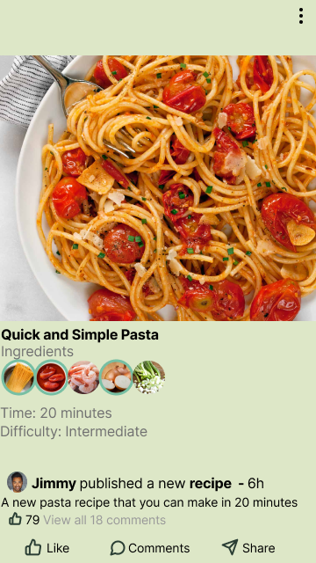

A recipe post has common components of a post in social media apps such as status message, timestamp, likes, comments counts, and interactable buttons. On top of it, the post also contains a summary of the recipe including name, ingredients, time, and difficulty. The post also checks for ingredients that the user already has and highlights them with subtle green circles.

## Filter-Recipe Courses screen:

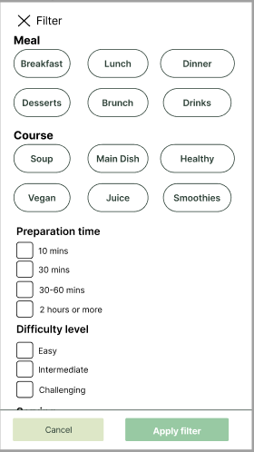

The filter-recipe courses view will show up when user click on icon filter right next to omni search bar in social media view. Here, the user can select what meal and course they want as well as the desired preparation time, difficulty level and number of people to be served then hit “Apply filter” button.

## Recipe Details screen:

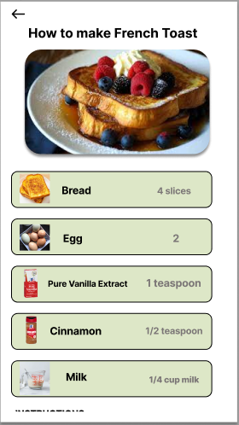

When users select “Recipes” button in the bottom of the app, it will lead to recipes view. Click on any recipe posts to show more details of how to make that dish. For example, if user click

“French Toast” post, it will show him or her steps to make French toast. User can see ingredients name on the left-hand side and quantity required on the right-hand side. Scrolling down to see instructions, the rating stars, number of total likes and comments as well as add a comment section. Plus, there is an icon inside the instructions, click on it to show a pop-up tip/reminder window.

## Manage ingredients and Search/add ingredients screens:

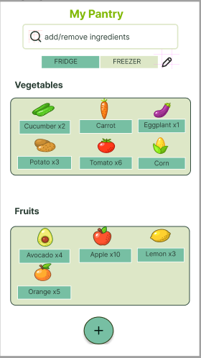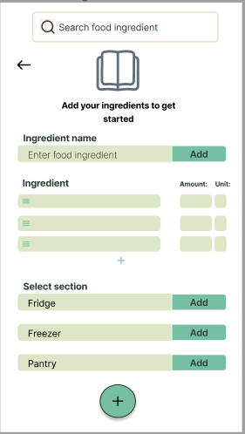

Click on ingredients list above "Recipes" text to show manage ingredients also known as My Pantry screen. There are vegetable and fruits lists in the fridge section. Users can click on the freezer section to see what items are in there. Users can also add additional sections by clicking icon pencil and name the new sections that they want to add. If users would like to make some changes such as add new ingredients into either the fridge or freezer section, they just need to click the "add" button at the bottom to pop-up search or add ingredient screen. In this screen, users can enter the ingredient name in the search bar to check if the specific ingredient is already in the pantry. If not, users can enter the ingredient name, the amount of it and the unit, then they select the sections they wish to add in.

## Recipe view:

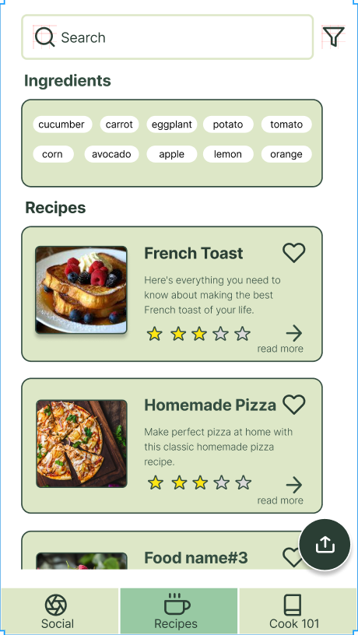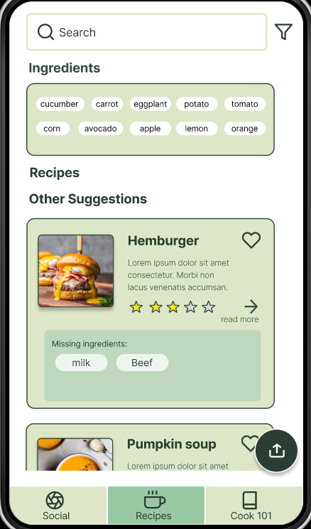

The recipe view shows a list of recipes according to the input ingredients. Users could keep scrolling down to see more options. Also, after all the most relevant recipes, there is a section for other suggestions that shows the recipes that the user misses a few ingredients. When they click the “read more” button, the recipe details mentioned would appear.

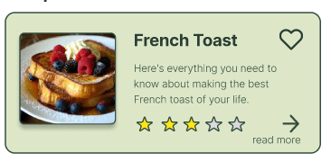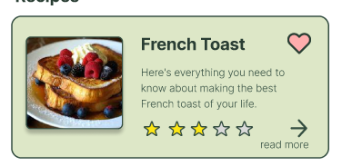

Users could like a recipe by clicking the heart icon. And it would store in a favorite recipe list.

## Recipes filter:

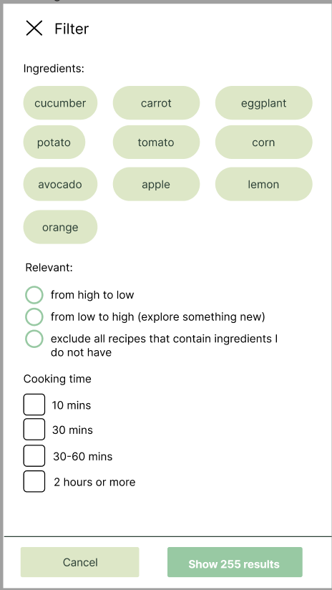

At the top of the screen, there is a search bar for searching recipes with keywords and a filter button. After clicking the filter icon, a filter pop-up page will appear. In that, users could unselect some ingredients that they do not want to use, select the desired options and filter recipe searching results according to their preferences. Users could select multiple options in the checkbox lists while only one select is allowed for the radio button list. By clicking the “cancel” button, they could cancel all the filter settings.

## Create a new recipe:

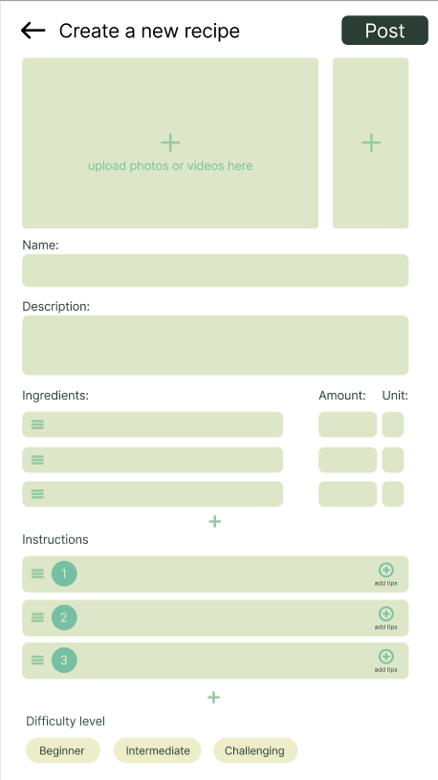

The floating action button at the bottom right corner takes users to create a new recipe page so that they can upload their own recipes by filling up the fields. The plus sign icon is for users to add extra fields if needed. They can change the order of the fields by dragging and dropping the hamburger icon on the left side of the field.

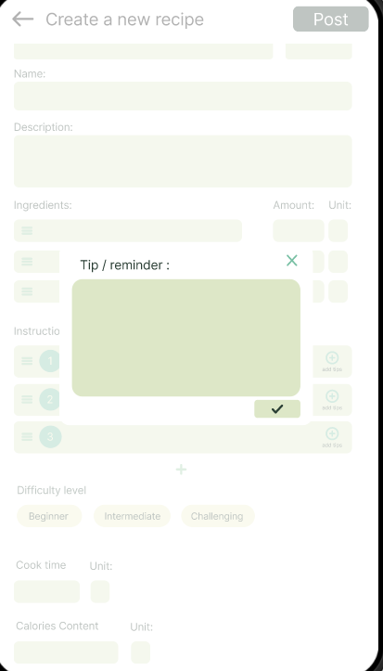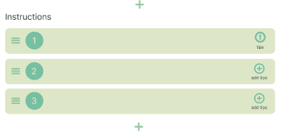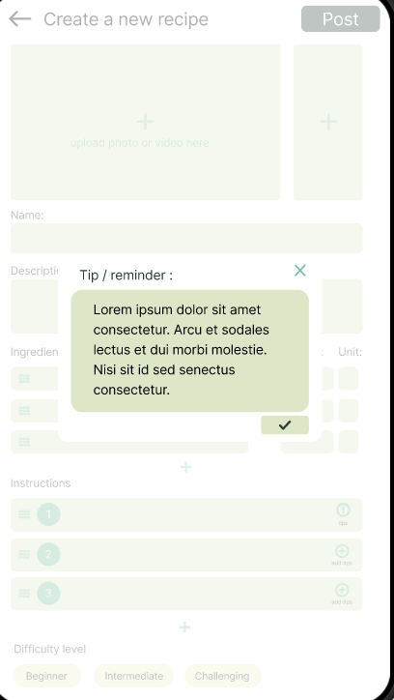

In the instruction section, the adding tips icon allows people to add their tips or reminders to a specific step so that viewers can follow the steps better. After adding it, the icon will change to an exclamation mark. Users can view or edit the tips by clicking them.

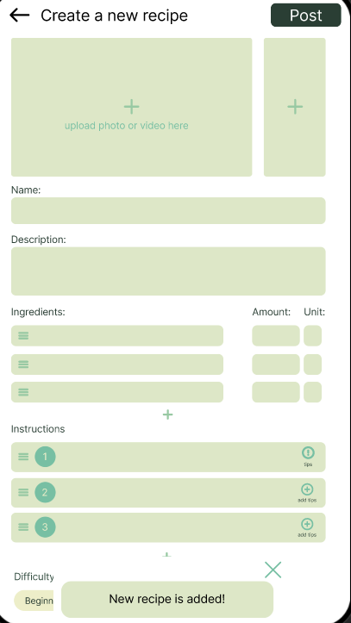

After entering all the fields, pressing the “post” button can update the recipe, and then the pop-up confirmation would appear.

## Cook 101:

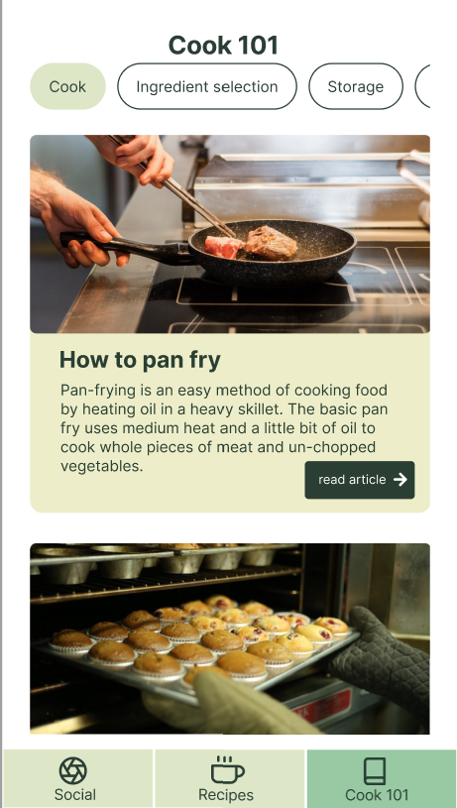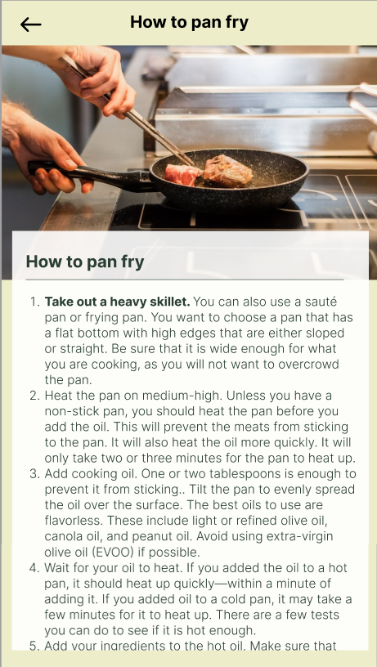

Cook 101 page shows a list of articles to teach beginners basic cooking techniques. Tags at the top could be scrolled horizontally to show different topics like storage and cleaning. Below is the article list which could be scrolled vertically. After clicking the “read article” button, the full content would be shown with videos and photos.

# Conclusion:

We believe that our design project has achieved the main goals by providing some new solutions and featured such as an effective way to manage leftover ingredients, social media platform allows users to share cooking moments, cook 101 with different sections for cooking tips and more. We will continue to keep track of various metrics such as the amount of food waste generated by users before and after using the app. Similarly, user feedback and reviews can also provide us valuable insights into whether the app is meeting user needs and expectations. Finally, surveys can be used if needed to gather feedback and identify areas for improvement.

From this project, we learned that there are many important steps with designing a project before building the actual app. The project goes through multiple redesigns after testing out the prototype, gathering and analyzing feedback. The final design can be very different from the initial concept as they need to be practical for the app to be successful. Once committed to writing the app, it will be difficult to go back to the design and change it. Ultimately, we learned that there are other important aspects to creating a successful product other than programming it.